**Title**

**Authors**

**Abstract**

**Introduction**

**Contribution**

**Related Work**

**Data**

**Methodology**

* Creation of initial clusters
  + The variable selection process is detailed in the CIG paper
  + We ended up with 4-5-6 cluster solutions for each of the chosen clustering approaches.
    - Gaussian Mixture Models
    - K-means
    - Archetype analysis
    - k-maxoids
* Chosen data set
  + We decided to focus on the PvP dataset, mainly because we thought the KA/D ratio was a better metric of performance in the PvP game modes
  + In PvP, KA/D can be inflated by no-skill-required-activities such as farming specific enemies or easy missions for loot.
    - Possible citations
      * Loot cave farming: <http://kotaku.com/bungie-explains-why-they-really-killed-destinys-loot-ca-1689513172>
      * Repeatedly killing character to farm for loot drops using the three-of-coins item, which increases the drop rate of exotic items.
        + <https://gamerant.com/destiny-bungie-three-coins-exploit-127/>
  + The data set has 4670 players assigned to 4 different clusters
    - The chosen cluster method is archetype analysis, as it provided the most interpretable and actionable cluster prototypes.
* Description of inverse classification approach
  + The Aggarwal paper provides a detailed explanation of the approach
  + As described in the paper, the approach is suited well for decision support systems where a specific set of actions can maximize a pre-defined criterion.
  + The approach defines ‘action-oriented’ variables to maximize the classification accuracy for a target class
* Creation of target class and treatment of feature variables
  + The target class is a discretized version of KA/D ratio. The variable is converted to a quintile representation (i.e. 1-5)
  + The quintiles are calculated using the entire 4670 data set.
  + The algorithm is run using each of the 4 clusters as input.
  + The chosen variables are divided into a set of variables that a player can control and potentially improve, as well a a set of variables that are treated as fixed. These fixed variables are included to allow for more diversity among the test instances. Otherwise, all players with the same target class would receive the same set of recommendations.

|  |
| --- |
| **Free Variables** |
| closeCalls_q |
| longestKillDistance_q |
| propResPerfRec_q |
| propAbilityKills_q |
| propDominationKills_q |
| propDefensiveKills_q |
| propPrecisionKills_q |
| propOffensiveKills_q |
| propMedalsActivityCompleteControlMostCaptures_q |
| propMedalsBuddyResurrectionMulti_q |
| propMedalsActivityCompleteCycle_q |
| propMedalsFirstBlood_q |
| propMedalsKillHeadshot_q |
| propOrbsDroppedTime_q |
| propOrbsGatheredTime_q |
| relicsCaptured_q |
| propSuicides_q |
| pvp.averageRemainingTimeAfterQuitSeconds_q |
| pvp.averageKillDistance_q |
| pvp.propWeaponKillsAutoRifle_q |
| pvp.propWeaponKillsFusionRifle_q |
| pvp.propWeaponKillsGrenade_q |
| pvp.propWeaponKillsHandCannon_q |
| pvp.propWeaponKillsMachinegun_q |
| pvp.propWeaponKillsMelee_q |
| pvp.propWeaponKillsPulseRifle_q |
| pvp.propWeaponKillsRocketLauncher_q |
| pvp.propWeaponKillsScoutRifle_q |
| pvp.propWeaponKillsShotgun_q |
| pvp.propWeaponKillsSideArm_q |
| pvp.propWeaponKillsSniper_q |
| pvp.propWeaponKillsSuper_q |
| pvp.propWeaponKillsSword_q |
| propPvp_q |

|  |
| --- |
| **Fixed Variables** |
| highestLightLevel_q |
| averageLifespan_q |
| longestKillSpree_q |

* Running the algorithm
  + Two criteria determine how quickly the algorithm will converge as well as how many combinations of features will be explored.
  + The support threshold is the number of records inside a given inverted list.
  + The gini threshold is an entropy measure that determines how discriminative an inverted list is with respect to the target class.
    - f(i,q,s) is the fraction of records in L(i,q) corresponding to the class index by s = {1, 2, …, k}

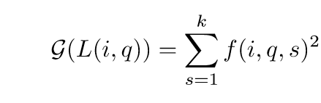

* + The following criteria were used for clusters 1-3
    - 60 support threshold
    - .2 gini threshold
  + The following criteria were used for cluster 4
    - 240 support threshold
    - .2 gini threshold
    - The higher support was necessary to allow the algorithm to run in a reasonable amount of time. The amount of pairwise comparisons required for certain test records exploded in size to the order of tens of millions.
  + First, the set of all singleton lists corresponding to a single feature are generated. Pairwise intersections are repeatedly performed with this set of singleton lists, with new lists failing to meet our criteria being pruned away.
  + Once all new intersections fail to meet the criteria, the list with the largest gini index is chosen and the associated variables and values are used to fill a test example
  + Once chosen, all lists that are inconsistent with the already-filled values are removed.
  + Once all are removed, the list with the next-largest gini index is chosen.
  + There is no guarantee that all variables will be filled once all consistent combinations of feature variables have been explored.
  + The unfilled variables are assigned whatever quintile they originally held before the algorithm was run.
  + The final output is a numeric vector of quintile values whose indices correspond to the chosen set of ‘action-oriented’ variables.
  + The proposed changes to quintile values are found by calculating the difference between the recommendation vector values and the original player attribute quintiles.
  + Since the chosen set of variables are subject to change via player agency, the player can take the provided recommendations and adjust their playstyle accordingly.
* Now that we’ve identified these suggested changes, we use parallel coordinate plots to search for patterns within each cluster of players.
* Additionally, we examine whether these patterns align with the behavioral characteristics of each cluster

**Results**

* Overall observation:
  + When we overlay parallel coordinates plots of the original values and the suggested changes, we notice that for the least-skilled players w.r.t to our chosen KA/D ratio metric, there are clear and definite patterns
  + It appears that there are a few ‘obvious’ changes that less skilled players can make to improve their performance.
  + As we examine players of higher skill levels (i.e. ascending KA/D ratio quintiles from 2-4), the suggested values become increasingly noisy and hard to interpret.
  + Interestingly, this pattern does *not* hold for the cluster of players that we labelled as marksmen, which play lots of PvP and have a high average kill distance.
  + **NOTE: All plots have a ‘jitter’ applied to increase the visibility of patterns in the data**
* Per cluster Observations: For each cluster, we derive initial hypotheses of what sort of recommendations would be unique to a particular playstyle. We examine the initially poorest performing players to see if any strong recommendation patterns emerge.
  + Cluster 1: Objective Killers, High proportion of offensive and defensive kills
    - Initial Hypotheses:
      * Since this cluster appears to be associated with players that spend a lot of their time in the ‘Control’ Crucible game mode, weapons and abilities suited for controlling areas might be emphasized.
      * Grenade usage might be emphasized, as certain types are geared toward controlling areas of the map. (solar grenades, storm grenades, spark grenades).
      * Some medal types that encourage more aggressive play might be de-emphasized (for example, first blood kills), as getting kills in control modes isn’t as important as holding down a specific area.
    - Note that our analysis does not break down kills by the type of grenade, so we lose some granularity here.

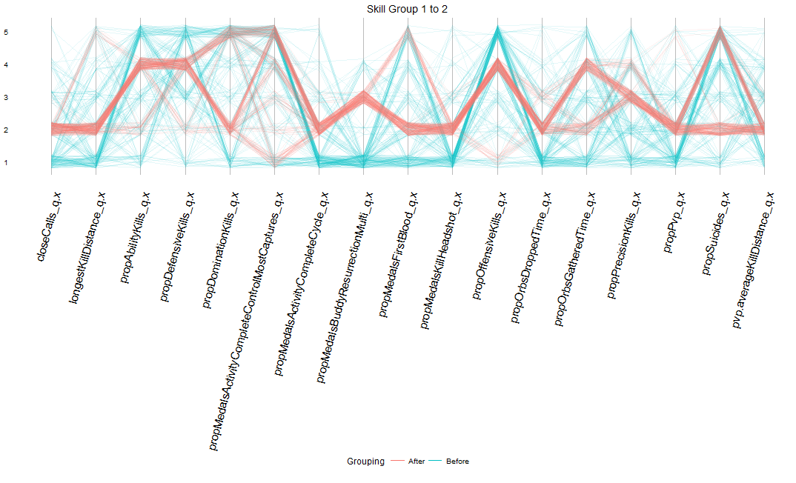

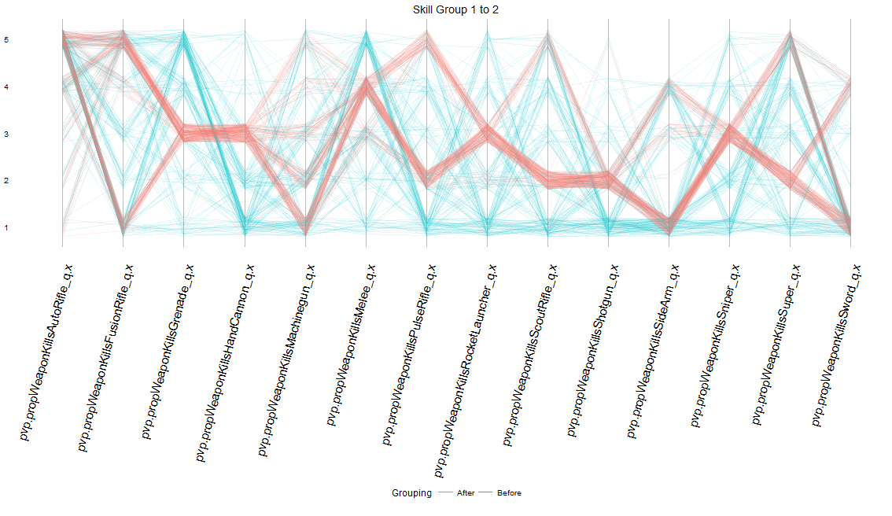

* A clear pattern of recommendations emerges for both weapons and general characteristics
* Interestingly, there are several split recommendations for the suggested types of weapons to use. For example, fusion rifle usage is suggested to be either 1 or 5. This suggests that there might be subgroups within the cluster that excel at either close or long range combat. Despite this, almost all recommendations point to a melee kill value of 4. In general, melee kills appear useful for members of this cluster. In terms of our initial hypotheses, there does not appear to be a suggested increase in grenade usage. In fact, it appears that most players are encouraged to decrease their use of grenades.
* Compared to the original values, the algorithm seems to suggest a slight decrease in the number of offensive kills (i.e. assaults on an enemy controlled area). Additionally it appears that slightly more aggressive behavior is encouraged. For example, compared to the original values, the recommendation seems to point to getting slightly more first blood medals (i.e. getting the first kill in a match). Strangely enough, there is a sizable chunk of players that are encouraged to commit more in-game suicides.
  + Cluster 2: Casual PvPers, Generally play less PvP
    - Initial Hypotheses:
      * The immediate and obvious suggestion would be to increase the proportion of time spent playing PvP in order to increase performance.
      * In regard to weapon usage, the possible suggestions aren’t as obvious. At the time of the data collection, the gameplay meta revolved around pulse rifles, snipers, and machine guns, so we might expect suggestions to gravitate toward use of these weapons.

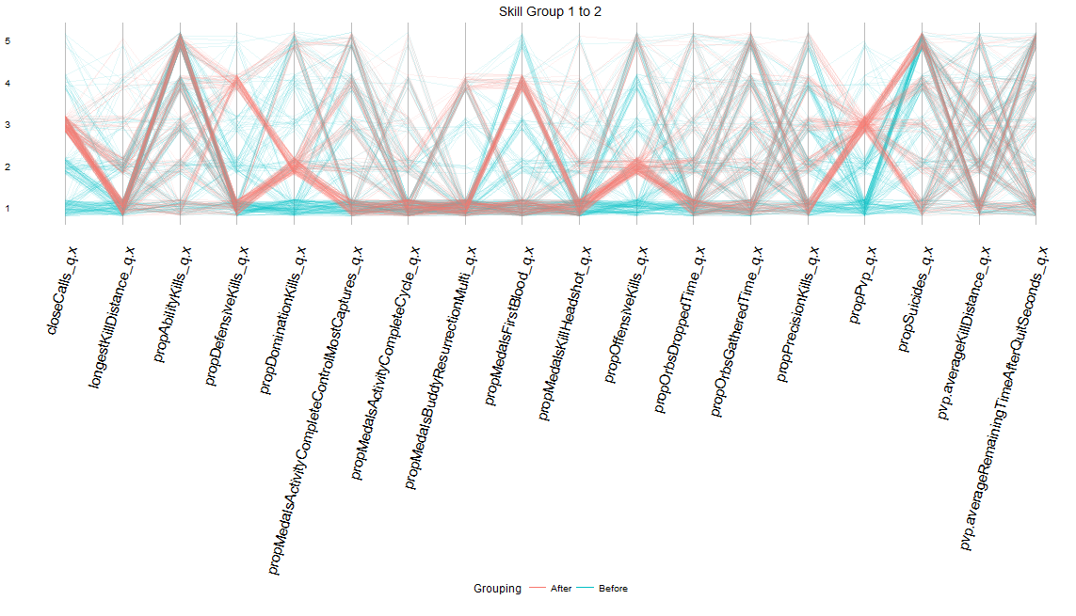

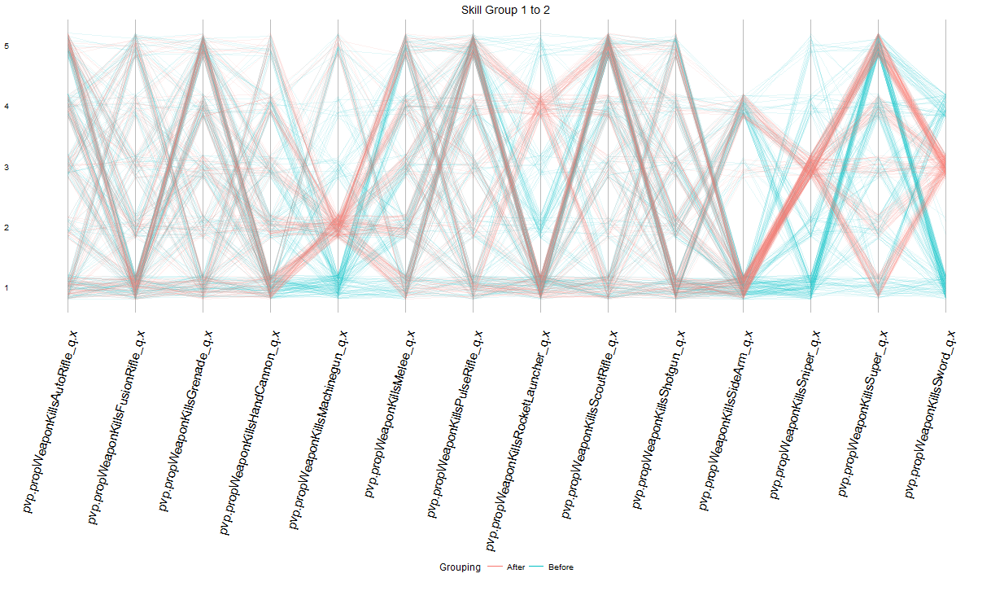

* For the 2nd cluster, the weapon suggestions do somewhat line up with initial expectations. In general, it appears that there is an emphasis on increased usage of machine guns and sniper rifles.
* For other characteristics, there is a suggested increase in the proportion of time spent in PvP, which makes intuitive sense. Interestingly, there does appear to be a general encouragement of more aggressive behavior in the form of first blood medals and close call medals (i.e. barely having any health before finishing off an enemy).
* In total, the recommendations seem to encourage less experienced PvP players get into the fray and be more aggressive in order to increase their performance.
  + Cluster 3: Aggressive Close Range, Lowest Average kill distance, highest melee and shotgun kills
    - Initial Hypotheses:
      * Medals Headshot & Proportion Precision Kills increase as accuracy increases. Because this type of player excels in close combat, it is crucial for them to be accurate at a close range.
      * This group probably gets killed far more often than other groups because they’re very close to the enemy, so high performance players should be efficient with resurrection variables
      * Weapons wise, we expect experienced players to be more distinctly stratified, focusing a lot on melee and close range weaponry

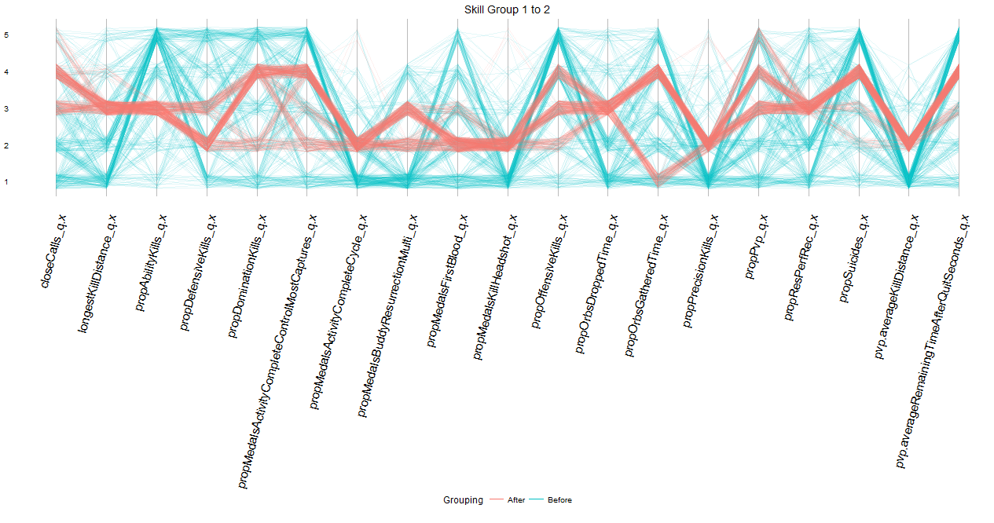

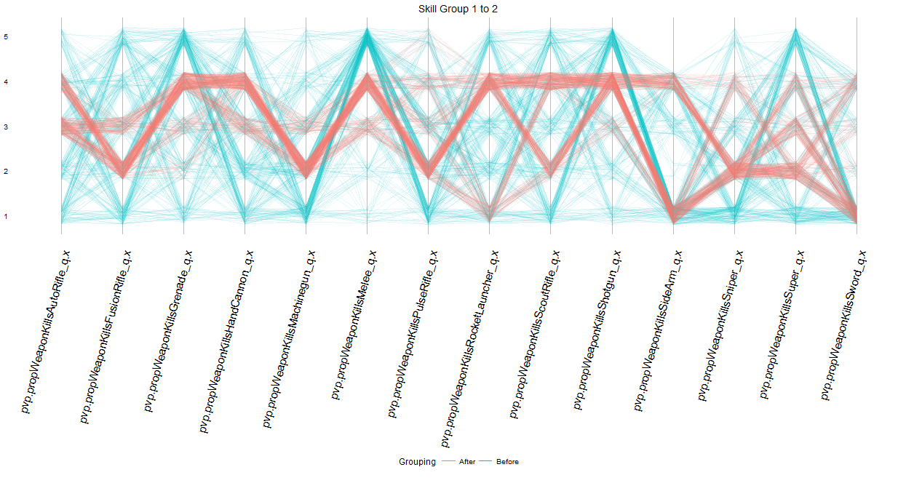

* There is a slight emphasis on increased precision, as there is a 1 category increase for both headshot medals and precision kills in the suggested output.
* There is a general encouragement to be more supportive of teammates. This is manifested through an encouraged increase in resurrection medals and the ratio of resurrections performed to received. While these players are more likely to die due to their behavior, they can mitigate these issues by keeping their teammates alive.
* In general, there is an encouragement to diversify playstyle by using longer range weapons and increasing the average kill distance. FOr example, there is a recommended increase of 1 for sniper usage, a recommended decrease of 1 for melee usage, and a recommended increase of 1 for average kill distance. This runs somewhat contrary to our initial hypothesis, as we thought it might be best for the close-range cluster to double down on their preferred behaviors.
  + Cluster 4: Marksmen, Highest average kill distance, highest hand cannon and sniper rifle usage, plays PvP the most
    - Initial Hypotheses:
      * Longer distance spread between you and the enemy
      * Even less usage of mid-range weapons
      * Medals Headshot & Proportion Precision Kills increase as accuracy increases (this player takes down enemies before they reach him, so accuracy should be paramount). This type of player also gets the drop on many enemies, so the number should be higher than the other segments.
    - Note that a different initial skill level is used here because the skill level 1 data subset was too sparsely populated.

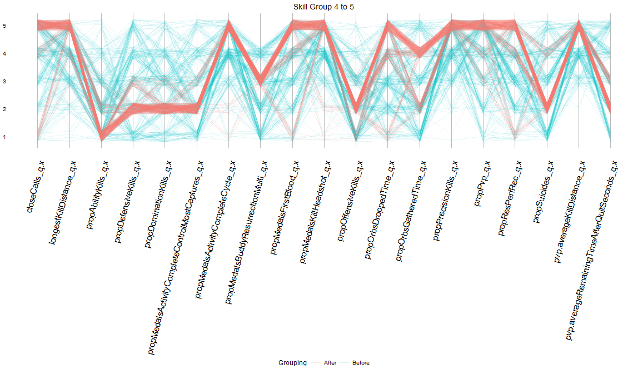

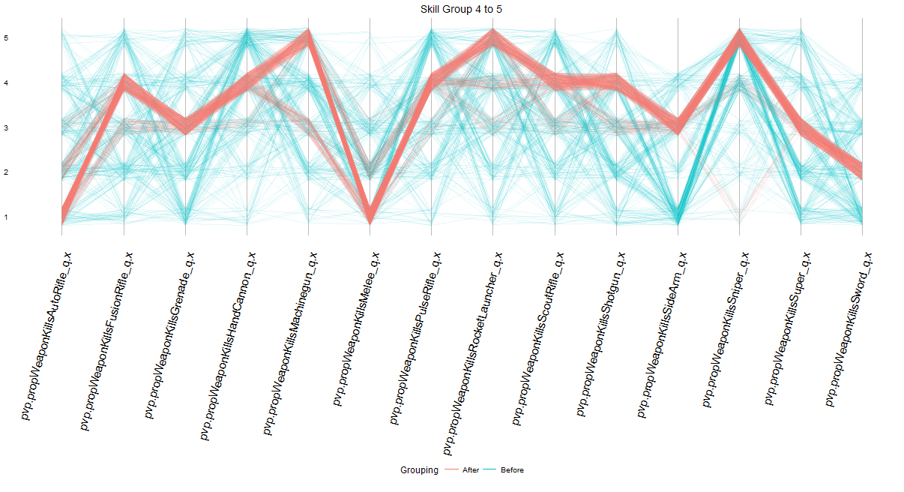

* It appears that the ‘marksmen’ clusters contains the most skilled Destiny players. In addition, there appears to be a very specific combination of traits that define the best players in the game.
* In contrast to the short range players in cluster 3, the recommendations here involve pushing the existing traits to their extremes
* To meet the skill level of the best in this cluster, players must spend most of their time in the crucible, and play very aggressively at a long range. Average kill distance, close calls, and First blood medal recommendations are almost entirely category 5.
* For those players in game modes where resurrections are permitted, the ratio of resurrections performed to received must also increase.
* In terms of weapon usage, the recommended items seem to align with general gameplay meta at the time of data collection. The best players do not rely on melee kills, auto rifle kills or ability kills, but instead use scout rifles, pulse rifles, hand cannons, snipers, and long range heavy weapons such as rocket launchers or machine guns.

**Conclusions**

* The suggestions provided by the inverse classification algorithm generally aligned with initial expectations.
* The suggested changes are rarely drastic, suggesting that for the weakest players, only slight tweaks in certain behaviors could lead to a noticeable improvement in overall performance.
* This is promising to hear, as improved performance could lead to a more positive experience with the game, and improved long term engagement.

**Future Work**

* Repeating analysis with a larger data set should minimize the number of unspecified variables in the test instances
* While the parallel coordinates plots proved useful in identifying macro-level trends, with more data, clustering approaches could identify groups of variables that tend to vary together.
* Ideally, this approach could be applied in a longitudinal fashion to a pre-defined set of Destiny players.
* After suggesting changes to action oriented variables, we can determine if the performance of players has increased as feedback is provided by the algorithm.

**Images**

**Overall Observations**

The below images are parallel coordinates plots where the vertical axis corresponds to a quintile value ranging from 1-5. Each player in the dataset corresponds to a single traced line. Each vertical line corresponds to a different variable in our data set. The green lines correspond to the initial values of players in the cluster before any recommendations are made. The orange lines correspond to the output from the inverse classification algorithm. Each plot corresponds to an initially similarly performing set of players in the cluster. For example, the first plot shows all players that initially were in the bottom 20% of players w.r.t KA/D ratio (quintile value 1), with the algorithm making suggestions based on a target KA/D in the top 40% (quintile value 2) Note that all plots below are from the 1st cluster, though similar patterns were seen for clusters 2 and 3. In these cases, it appears that there is a set of ‘universal’ or ‘obvious’ changes that very poorly performing players can make to incrementally improve their performance. As the initial skill of the players increases, however the suggestions become increasingly noisy suggesting that it becomes difficult to come up with a ‘universal’ set of suggestions for more skilled players.

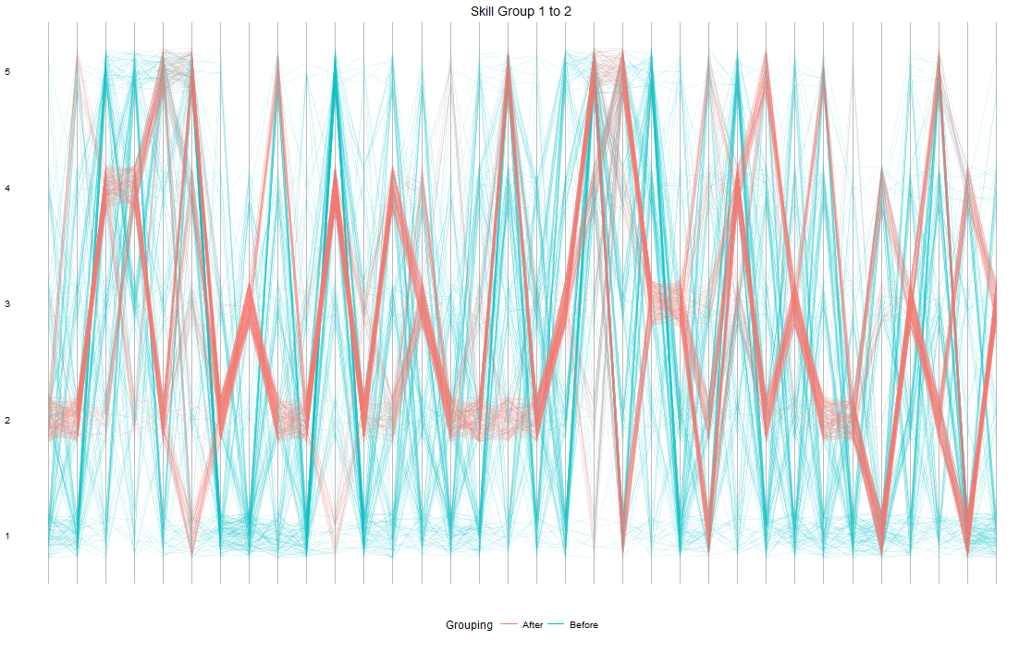

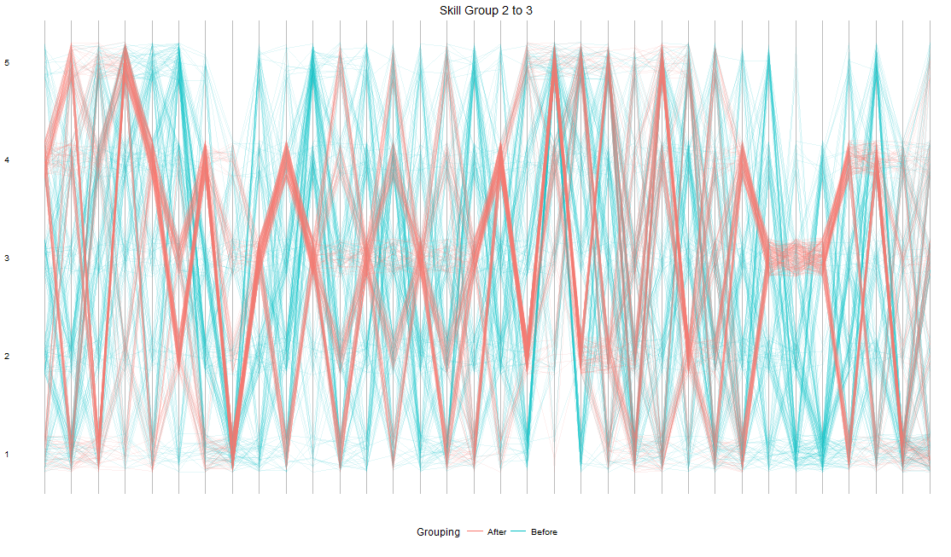

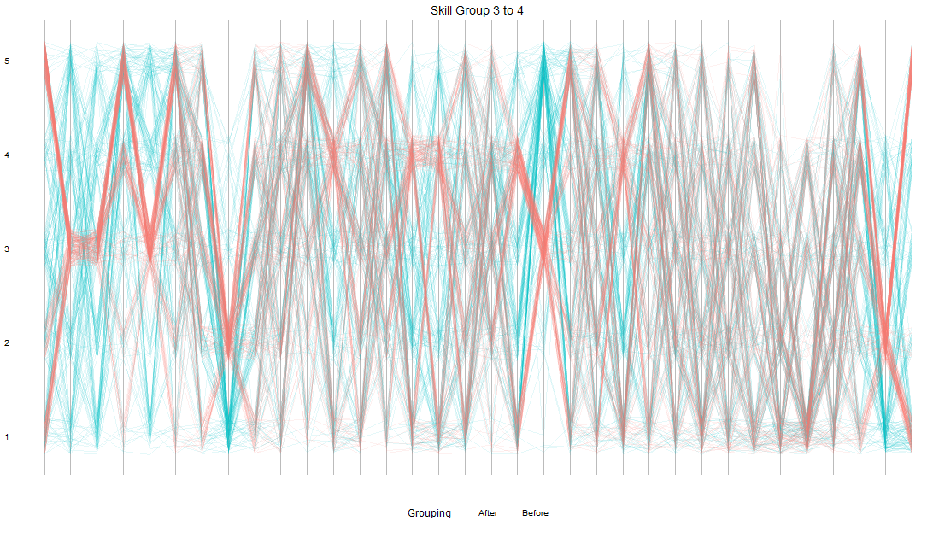

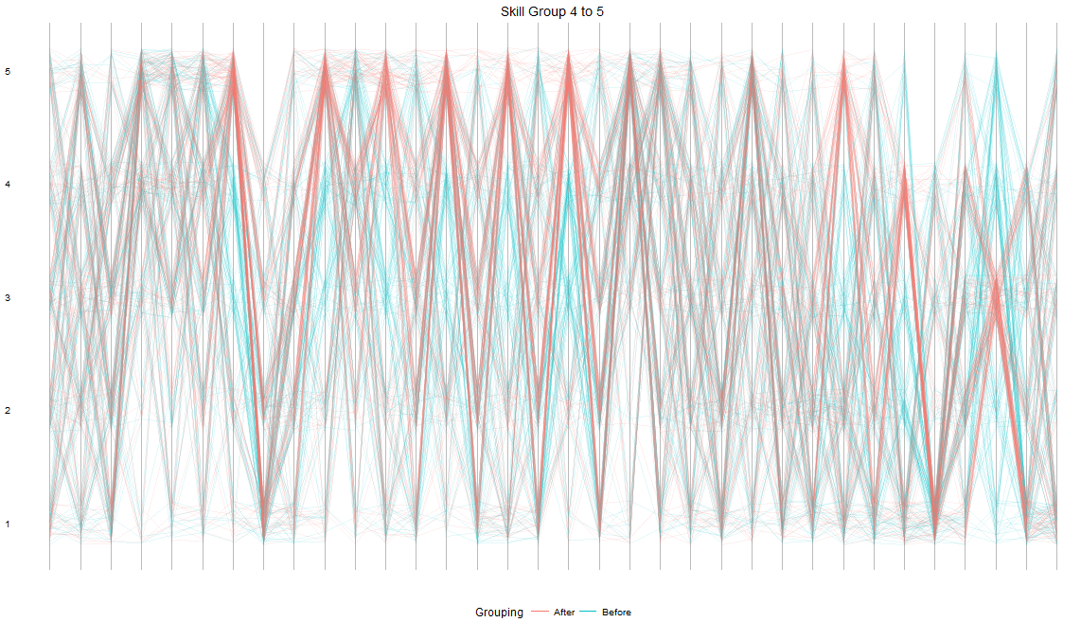

This pattern did not hold for the 4th cluster of ‘Marksmen.’ In fact, the members of this cluster appear to be the most skilled PvP players in Destiny, with the population of players in the bottom 20% for KA/D being quite sparse. Those looking to move from the top 40% to the top 20% w.r.t KA/D ratio have an extremely clear set of goal values.

